

HOTEL RESERVATION SYSTEM

**Software Requirement Specification**



**Submitted**  **By:**

**NITHYA SHREE.S**

**SANTHIYA.GM**

**DHANU SREE.B**

# 1 INTRODUCTION

The Hotel reservation System is a tool for booking the rooms, guest details and billing of Hotel through the Hotel staffs. It provides the proper management tools and easy access to the guest information.

### 1.1 Purpose

The main objective of this document is to illustrate the requirements of the project Hotel Reservation System. This Hotel Reservation System Software Requirement Specification (SRS) main objective is to provide a base for the foundation of the project. It gives a comprehensive view of how the system is supposed to work and what is to be expected by the end users. Client’s expectation and requirements are analyzed to produce specific unambiguous functional and non-functional requirements, so they can be used by development team with clear understanding to build a system as per end user needs.

This SRS for HRS can also be used for future as basis for detailed understanding on how project was started. This project describes the hardware and software interface requirements using ER diagrams and UML diagrams.

### 1.2 Scope of Development Project

It will be able to automate the various operations of the Hotel. Our Hotel Reservation System will have three end users: Guest, Staffs, manager. Hotel Reservation System will consists of Booking Management System, DBMS Server, and Report Generator. Guest will be able to check for room’s availability, select the rooms, and pay for the room. Receptionist will have access to update or modify booking details. Manager will able to view the financial report and able to update room information such as cost and category.

The main goal of this introduced automated HRS software is to simplify every day process of hotel. Day to day Hotels are increasing and they need to automate to provide customer ease of access. It will be able to take care of services to guest in a quick manner. This automation will be able to replace the drawbacks of large guest information physical files which were difficult to handle. Secure Transaction, quick retrieval of information, ease of use, quick recovery of errors, fault tolerance are some of the benefits that development team will be working on to achieve end user satisfaction.

### 1.3 Definitions, Acronyms and abbreviations

|  |  |
| --- | --- |
| SRS | Software Requirement Specifications |
| HMS | Hotel Reservation System |
| DBMS | Database Management System |
| Blueprint | A design technical plan |
| JAVA | Platform independence |
| JDBC | Java Database Connectivity |
| HTTP/HTTPS | Hyper Text Transfer Protocol/Secure |
| EJB | Enterprise Java Beans |
| API | Application Interface |  |
| OS | Operating System |
| JSP | Java Server Pages |
| RTM | Requirement Traceability Matrix |
| FR | Functional Requirement |
| NFR | Non Functional Requirement |

### 1.4 References

1. Software Engineering 9th Edition, Ian Sommerville
2. Fundamentals of Database System, 6th Edition, Ramez Elmasri, Shamkant B. Navathe
3. ER Diagram Tutorial: <https://www.tutorialspoint.com/dbms/er_diagram_representation.htm>
4. Requirement Engineering: <http://morse.inf.unideb.hu/valseg/gybitt/07/ch02.html>
5. Hotel Reservation System: [https://www.scribd.com/doc/63824633/Hotel-Management-](https://www.scribd.com/doc/63824633/Hotel-Management-System)

[System](https://www.scribd.com/doc/63824633/Hotel-Management-System)

1. Case Study: <https://www.scribd.com/doc/27927992/Hotel-Management-Case-Study>
2. Data Flow Diagram: <http://myyee.tripod.com/cs457/dfd.htm>
3. Requirement Engineering: <https://en.wikipedia.org/wiki/Requirements_engineering>

# 2 OVERALL DESCRIPTION

### 2.1 Product Perspective

*Figure 2.1**Product Perspective*

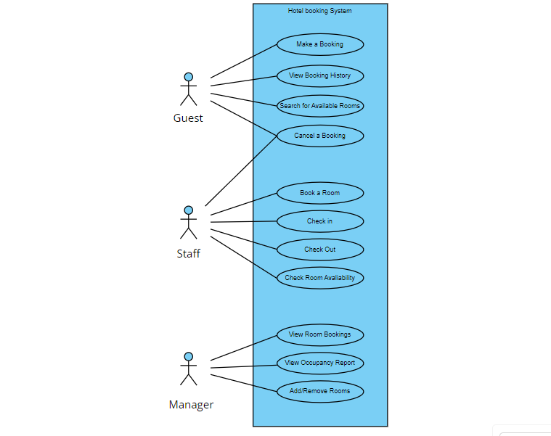

### 2.2 Product Functions

Our Product General functions are:

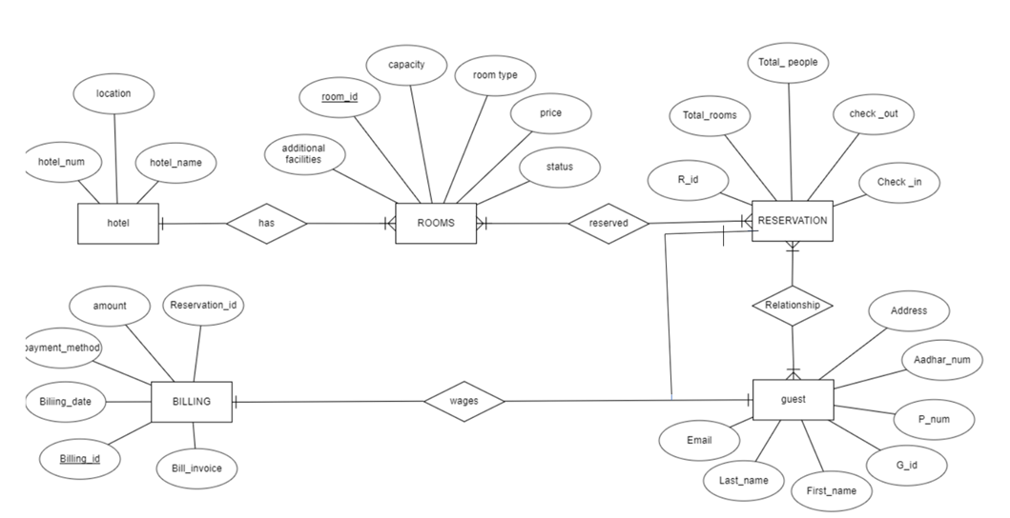

*Figure 2.2 System Architecture*

### 2.3 User Classes and Characteristics

There are 3 user Levels in our Hotel Management System:

1. Hotel Manager
2. Staffs
3. Guest

**Hotel Manager**

Manager have every access to the hotel system. Manager is solely responsible for managing hotel resources and staffs. Manager can view any report such as financial report, guest information, booking information, and room information, analyze them and take the decision accordingly. Manger is required to have experience on managing hotel previously, and have base knowledge of database and application server.

**Staff**

Hotel Receptionist sole purpose is to provide the quality customer service. She have least access than manager. She can manage the booking details. She can search for availability of rooms, add the guest, confirm the booking, and update the booking details. Manager of hotel would probably want the receptionist who have good communication skills and command over English language. She should have basic IT Knowledge.

**Guest**

Guest are vital part of the system. guest have access to view the vacant room information and price range. They should be able to confirm the booking and cancel it if necessary. Guest have access to customer service desk portal to forward their inquiry. Guest should at least be capable to use the web UI interface.

2.4 **Operating Environment**

The Hotel Reservation System is a website and shall operate in all famous browsers, for a model we are taking Microsoft Internet Explorer ,Google Chrome and Mozilla Firefox. Also it will be compatible with the IE 6.0. Most of the features will be compatible with the Mozilla Firefox & Opera 7.0 or higher version. The only requirement to use this online product would be the internet connection. The hardware configuration include Hard Disk: 40 GB, Monitor: 15” Color monitor, Keyboard: 122 keys. The basic input devices required are keyboard, mouse and output devices are monitor, printer etc.

**2.5 Assumptions and Dependencies**

**Assumptions:**

  1.Error free coding

2.User friendly System

3.Database for Guest,room, reservation and billing

4.Storage and speed

5.Search and quick transaction

6.24/7 operation

7.Acesses from any computer

8.User authentication

**Dependencies:**

1.Specific Hardware and Software

2.Project Development Based on Requirement

3.User Understanding

4.General Report Availability

5.Database assess for guest information

6.Accurate Recording of bookings

# 3 REQUIREMENTS

## 3.1 External Interface Requirements

#### 3.1.1 User Interfaces

The user interface for system shall be compatible to any type of web browser such as Mozilla Firefox, Google Chrome, and Internet Explorer.

#### 3.1.2 Software Interfaces

**Web Server**

* Javafx

**Database Server**

* **Microsoft SQL sever, Github .**

**Development End**

* **HTML, JavaScript, OS(Windows)**

#### 3.1.3 Hardware Interfaces

|  |  |  |  |
| --- | --- | --- | --- |
| **Server Side** | | |  |
| Monitor | Processor | RAM | Disk Space |
| Resolution:  1024x768 | Intel or AMD 2GHZ | 4GB | 10GB |
| **Client Side** | | |  |
| Monitor | Processor | RAM | Disk Space |
| Resolution:  1024x768 | Intel or AMD 1GHZ | 512MB | 2GB |

## 3.2 Requirements

#### 3.2.1 Registration

**FR1.** The Guest should be able to register with their details

**FR2.** The system should record following customer details into member database.

Name

Email

Password

Address

DOB

**FR3.** The system shall send verification message to email

#### 3.2.2 Logging In

**FR4.** The system should verify the customer email & password against the member database when logging in

**FR5.** After login, member should be directed to Home screen

#### 3.2.3 Reservation

**FR6.** The system should enable guest to check for availability of rooms

**FR7.** The system should display rate for all rooms

**FR8.**  The system should allow guest to confirm or cancel the booking

**FR9.**  The system should record booking details into database

#### 3.2.4 Staffs Access

**FR10.** The system should allow Receptionist to update, add or delete booking information

**FR11.** The system should provide customer desk portal access to receptionist for providing response to customer inquiry

#### 3.2.5 Manager Access

**FR12.** The system should generate financial and customer report for manager

**FR13.** The system should enable manager full modification access to customer ,booking and room information

#### 3.2.6 Payment Management System

**FR14.** The system should allow customer to pay bill via online using credit or debit card

## 3.3 Performance Requirements

**NF1.**  Data in database should be updated within 2 seconds.

**NF2.** Query results must return results within 5 seconds

**NF3.** Load time of UI Should not take more than 2 seconds

**NF4.** Login Validation should be done within 3 seconds

**NF5.** Response to customer inquiry must be done within 5 minutes.

### 3.4 Security Requirements

**NF6.** All external communications between the data’s server and staff must be encrypted **NF7.** All data must be stored, protected or protectively marked.

**NF8.** Payment Process should use HTTP over Secure protocol to secure the payment transactions (when it is online payment option)

### 3.5 Safety Requirements

**NF9.** Database should be backed up every hour.

**NF10.** Under failure, system should be able to come back at normal operation under an hour.

### 3.6 Capacity Requirements

**NF11.** System need to handle at least 20 transactions during peak hours.

### 3.7 Availability Requirements

**NF13.** Report should be generated automatically every day for manager and anytime upon request.

### 3.8 Software System Attributes

* **Correctness**: This system should satisfy the normal regular Hotel Management operations precisely to fulfill the end user objectives
* **Efficiency:** Enough resources to be implemented to achieve the particular task efficiently without any hassle.
* **Flexibility**: System should be flexible enough to provide space to add new features and to handle them conveniently
* **Integrity:** System should focus on securing the customer information and avoid data losses as much as possible
* **Portability:** The system should run in any Microsoft windows environment.
* **Usability:** The system should provide user manual to every level of users.
* **Testability:** The system should be able to be tested to confirm the performance and clients specifications.
* **Maintainability:** The system should be maintainable.

**APPENDIXES**

##### A: abbreviation, acronyms, assumptions B: booking, browser

##### C:customer,clients D:data,day E: efficiently F: flexible, features Q: Query

**M:** Maintainability, manager **N:** Non-functional Requirement

**P:**; Performance , Perspective, Purpose Requirement, Requirement attributes ***R:***; **S**: Safety, Scope,

**CLASS DIAGRAM**

